**Module 3 - PL/SQL Programming**

**Exercise 2: Error Handling**

**Scenario 1:** Handle exceptions during fund transfers between accounts.

**Question:** Write a stored procedure **SafeTransferFunds** that transfers funds between two accounts. Ensure that if any error occurs (e.g., insufficient funds), an appropriate error message is logged and the transaction is rolled back.

**OUERY:**

CREATE OR REPLACE PROCEDURE SafeTransferFunds (

p_from_account_id IN NUMBER,

p_to_account_id IN NUMBER,

p_amount IN NUMBER

) AS

v_balance NUMBER;

BEGIN

SELECT Balance INTO v_balance

FROM Accounts

WHERE AccountID = p_from_account_id;

IF v_balance < p_amount THEN

DBMS_OUTPUT.PUT_LINE('Transfer failed: Insufficient funds.');

RAISE_APPLICATION_ERROR(-20001, 'Insufficient funds in source account.');

END IF;

UPDATE Accounts

SET Balance = Balance - p_amount,

LastModified = SYSDATE

WHERE AccountID = p_from_account_id;

UPDATE Accounts

SET Balance = Balance + p_amount,

LastModified = SYSDATE

WHERE AccountID = p_to_account_id;

COMMIT;

DBMS_OUTPUT.PUT_LINE(' Transfer successful: ' || p_amount || ' transferred from account ' || p_from_account_id || ' to ' || p_to_account_id);

EXCEPTION

WHEN OTHERS THEN

ROLLBACK;

END;

/

**EXEC SafeTransferFunds(1, 2, 100);**

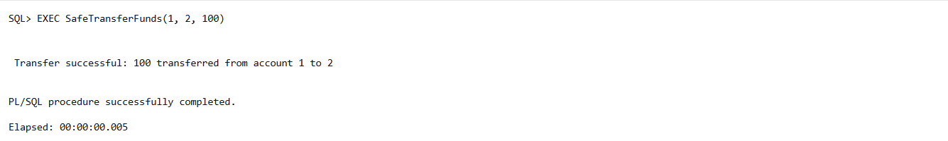

**EXEC SafeTransferFunds(1, 2, 999999);**

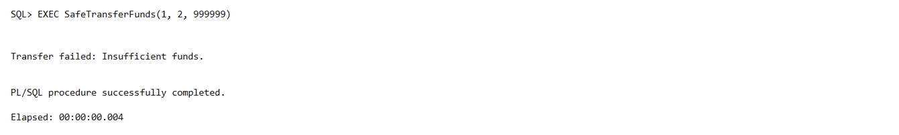

**Scenario 2:** Manage errors when updating employee salaries.

**Question:** Write a stored procedure **UpdateSalary** that increases the salary of an employee by a given percentage. If the employee ID does not exist, handle the exception and log an error message.

**QUERY:**

CREATE OR REPLACE PROCEDURE UpdateSalary (

    p_employee_id IN NUMBER,

    p_percentage  IN NUMBER

) AS

    v_old_salary NUMBER;

BEGIN

    SELECT Salary INTO v_old_salary

    FROM Employees

    WHERE EmployeeID = p_employee_id;

    UPDATE Employees

    SET Salary = Salary + (Salary * p_percentage / 100)

    WHERE EmployeeID = p_employee_id;

    COMMIT;

    DBMS_OUTPUT.PUT_LINE(' Salary updated successfully for Employee ID ' || p_employee_id);

    DBMS_OUTPUT.PUT_LINE('   Old Salary: ' || v_old_salary);

    DBMS_OUTPUT.PUT_LINE('   New Salary: ' || (v_old_salary + (v_old_salary * p_percentage / 100)));

EXCEPTION

    WHEN NO_DATA_FOUND THEN

        DBMS_OUTPUT.PUT_LINE('Error: Employee ID ' || p_employee_id || ' not found.');

    WHEN OTHERS THEN

        DBMS_OUTPUT.PUT_LINE(' Unexpected error: ' || SQLERRM);

END;

**EXEC UpdateSalary(1, 10)**

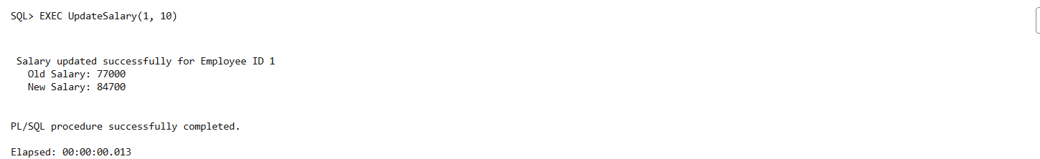

**EXEC UpdateSalary(9999, 15)**

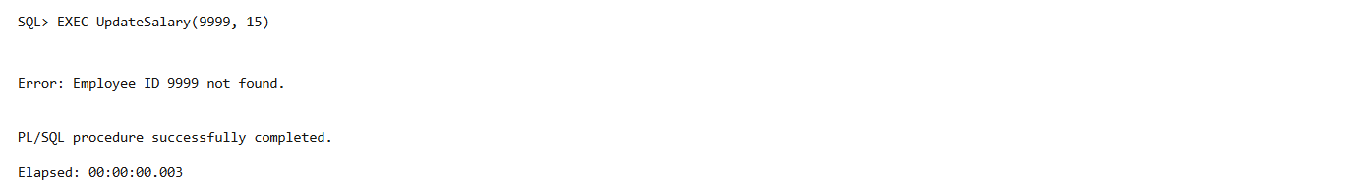

**Scenario 3:** Ensure data integrity when adding a new customer.

**Question:** Write a stored procedure **AddNewCustomer** that inserts a new customer into the Customers table. If a customer with the same ID already exists, handle the exception by logging an error and preventing the insertion.

**QUERY:**

CREATE OR REPLACE PROCEDURE AddNewCustomer (

    p_customer_id IN NUMBER,

    p_name        IN VARCHAR2,

    p_dob         IN DATE,

    p_balance     IN NUMBER

) AS

    v_dummy NUMBER;

BEGIN

    SELECT 1 INTO v_dummy

    FROM Customers

    WHERE CustomerID = p_customer_id;

    DBMS_OUTPUT.PUT_LINE(' Customer ID ' || p_customer_id || ' already exists. Insertion aborted.');

    INSERT INTO Error_Log (Error_Message)

    VALUES ('Attempted to insert duplicate Customer ID: ' || p_customer_id);

EXCEPTION

    WHEN NO_DATA_FOUND THEN

        INSERT INTO Customers (CustomerID, Name, DOB, Balance, LastModified)

        VALUES (p_customer_id, p_name, p_dob, p_balance, SYSDATE);

        DBMS_OUTPUT.PUT_LINE(' New customer added successfully: ' || p_name);

    WHEN OTHERS THEN

        DBMS_OUTPUT.PUT_LINE(' Unexpected error: ' || SQLERRM);

        RAISE;

END;

**EXEC AddNewCustomer(4, 'David Green', TO_DATE('1988-12-10', 'YYYY-MM-DD'), 2000);**

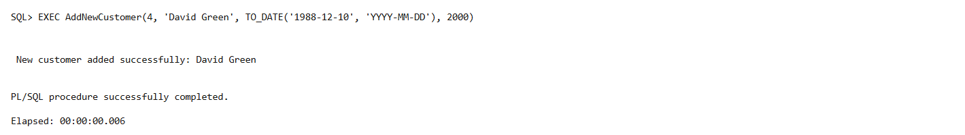

**EXEC AddNewCustomer(1, 'Fake John', TO_DATE('1995-11-11', 'YYYY-MM-DD'), 500);**

